DVD Red

1. Using DVD Red for connecting DVD to TV without Video Input

2. Using DVD Red for connecting DVD and VCR to TV with single Video Input.
You should not reconnect video cables every time you want to switch from DVD to VCR.

3. As a side effect, DVD Red will enable recording of the DVD media to the VCR. Such utilization of the device may be illegal and prohibited by law. All the responsibility of any illegal utilization of DVD Red lays on the customer.

DVD Red Connection scheme

Non regulated DC 9V

Plus Inside (+)

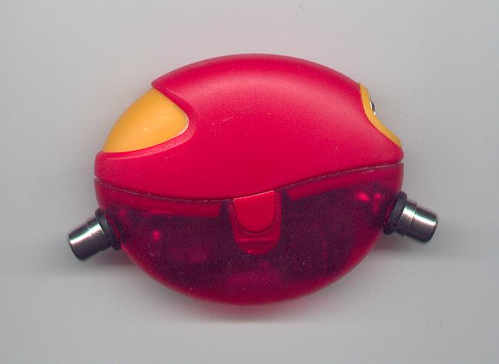

Video Signal Input/Output.

Dimax Ltd ©
www.xdimax.com
support@xdimax.com

